**EXPERIMENT:3 Create a simple cloud software application for Car Booking Reservation System using any Cloud Service Provider to demonstrate SaaS include the necessary fields such as search for cabs, from, to, rental , out station, Package type, hours/Days etc.**

**AIM:** To create a simple cloud software application for Car Booking Reservation System using any Cloud Service Provider to demonstrate SaaS.

**PROCEDURE**:

**step1**: Go to zoho.com

**step 2:** Log into the zoho.com.

**step 3:** Select one application step.

**step4:** Enter application name as Car Booking Reservation System.

**step 5:** Created new application as Car Booking Reservation System.

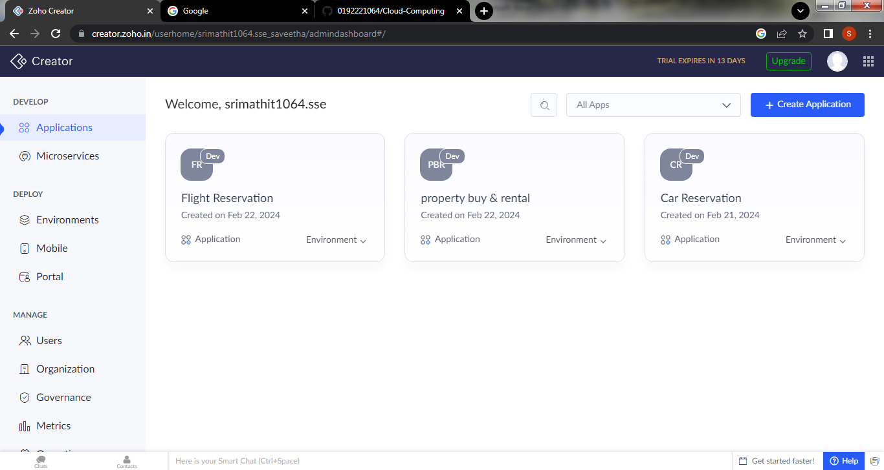

**Step 6**: Create a first form as Login page

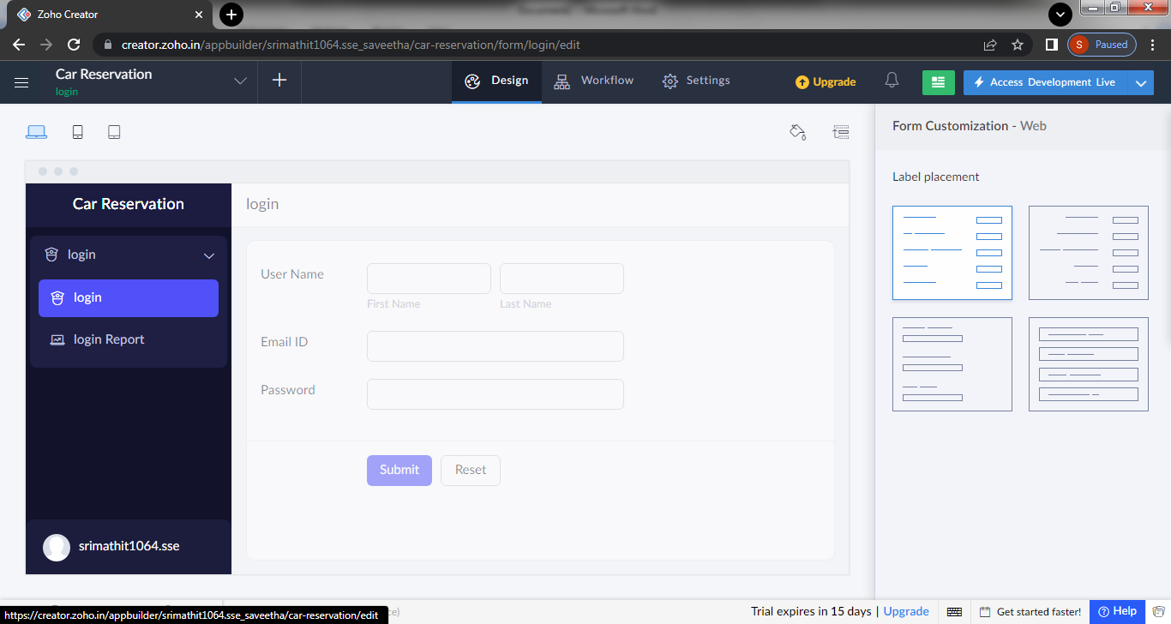

**Step 7:** create a second form for as the Verification page

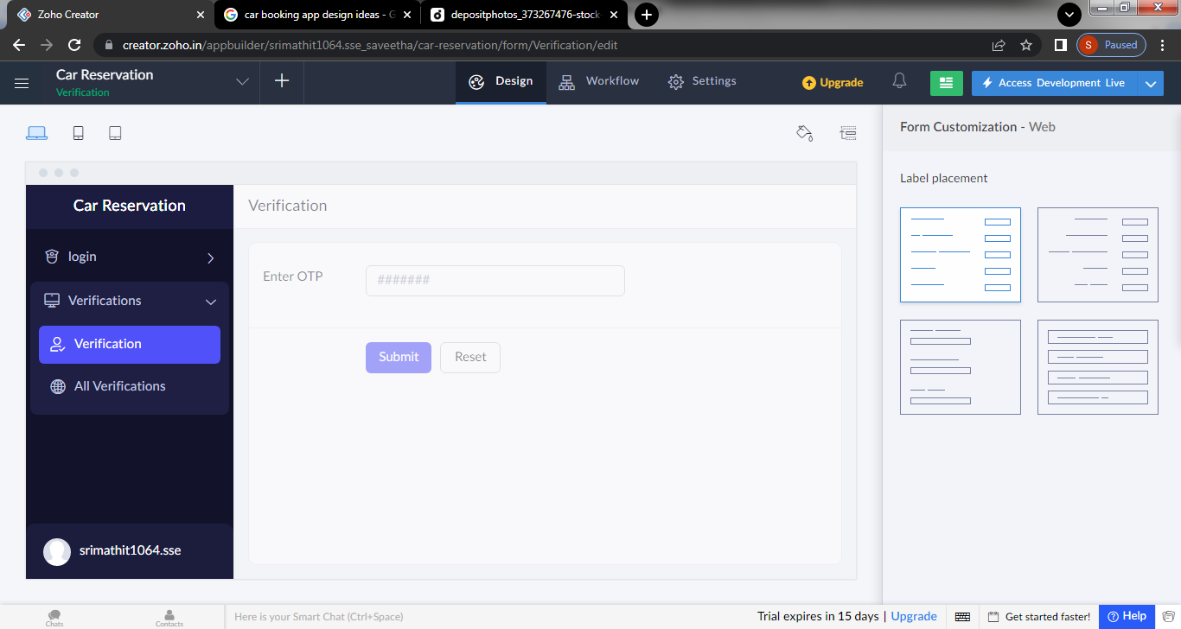

**Step 8 :**Create a third for Booking a cab

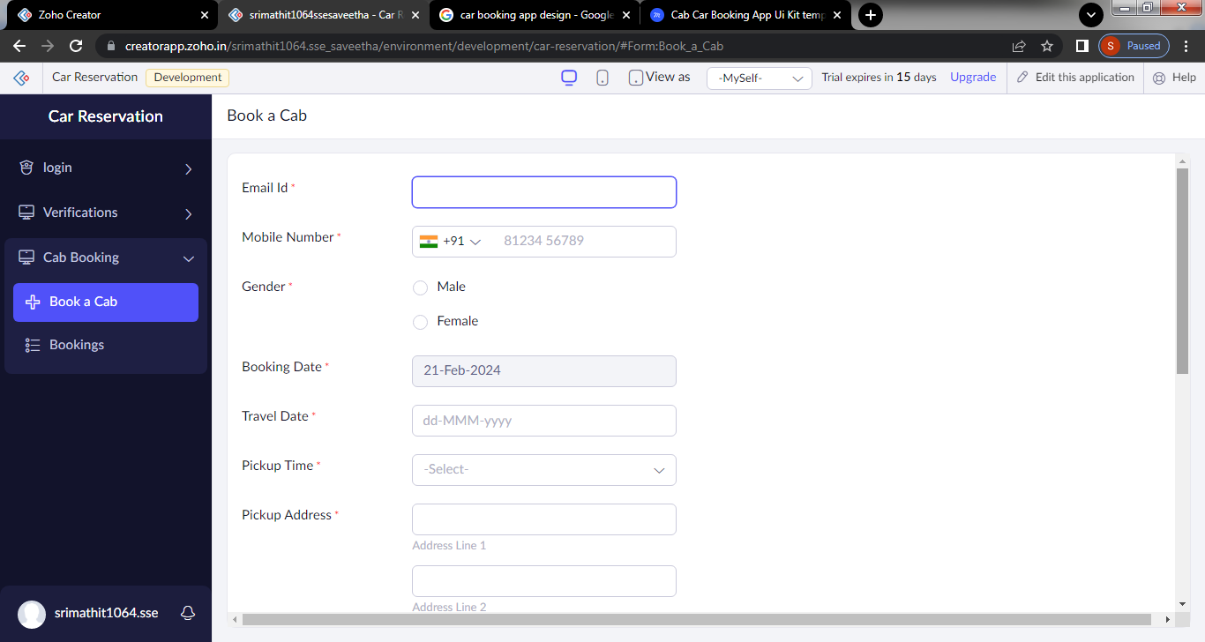

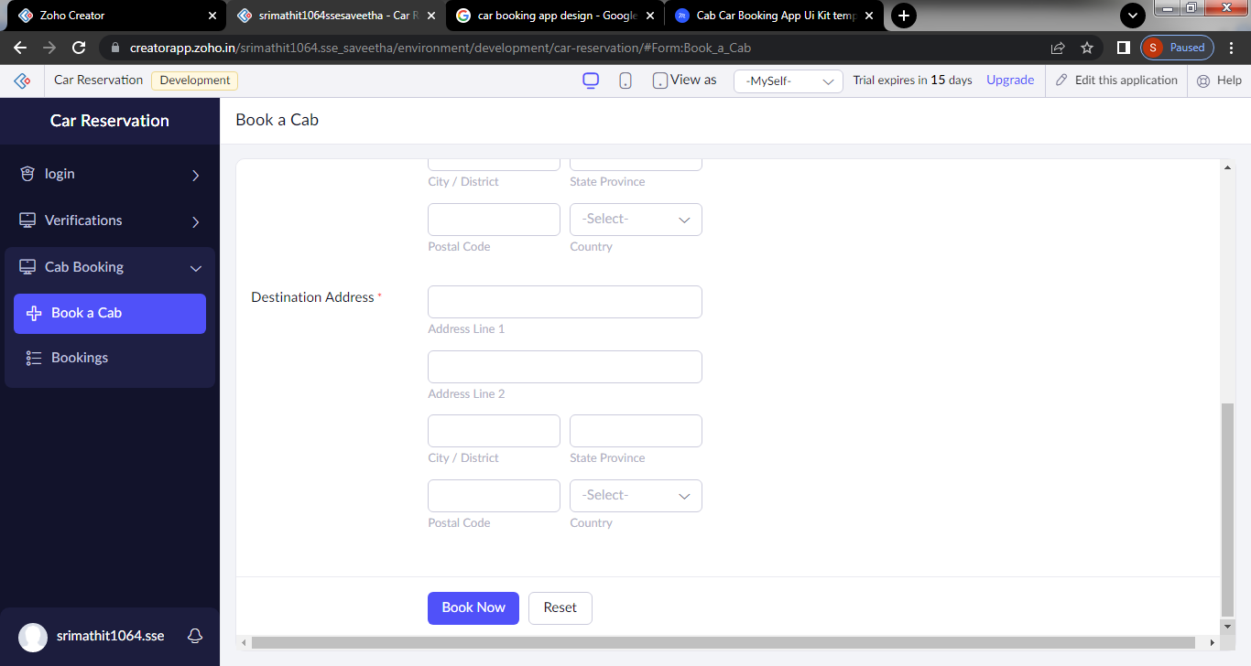

Step 9: create a form for Payment

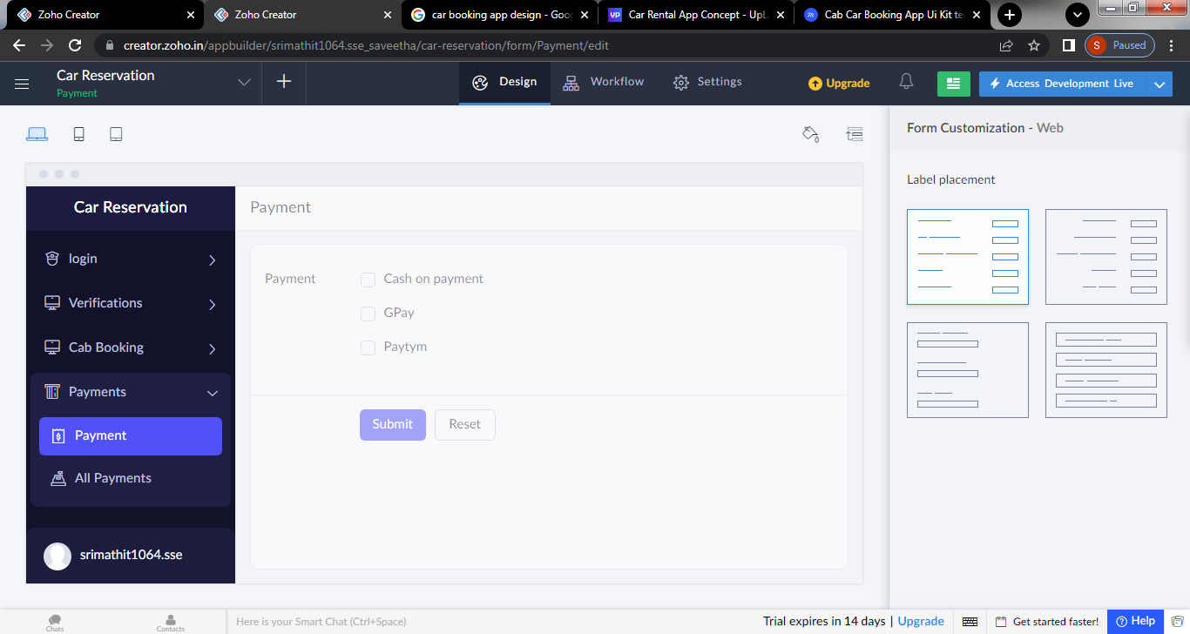

Step 10: click the access development to see the output

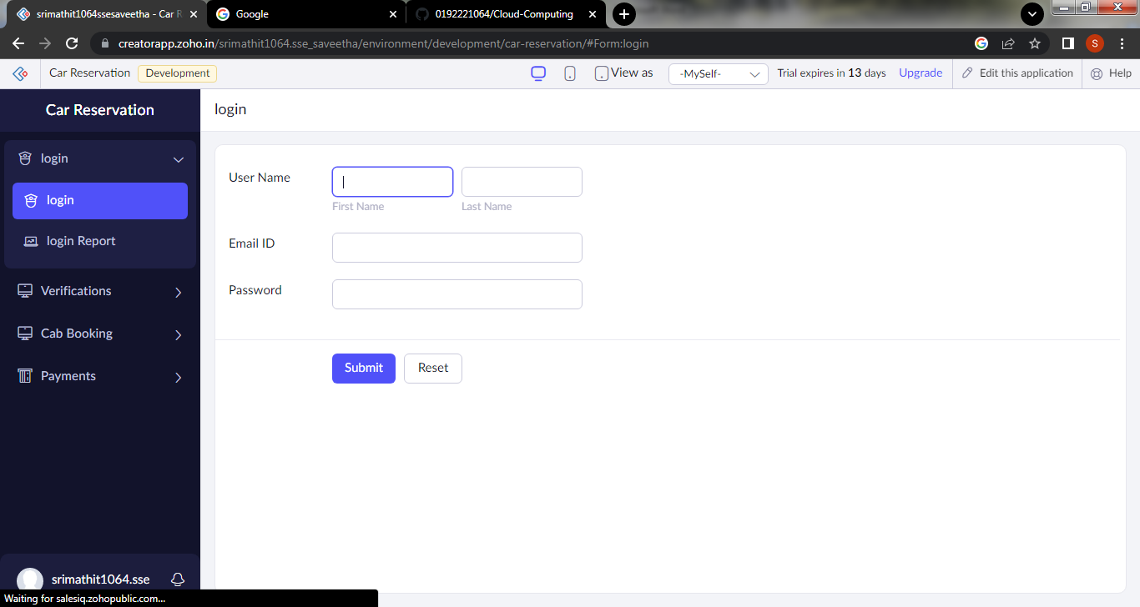

**Step 11:** click the report to see the car bookings

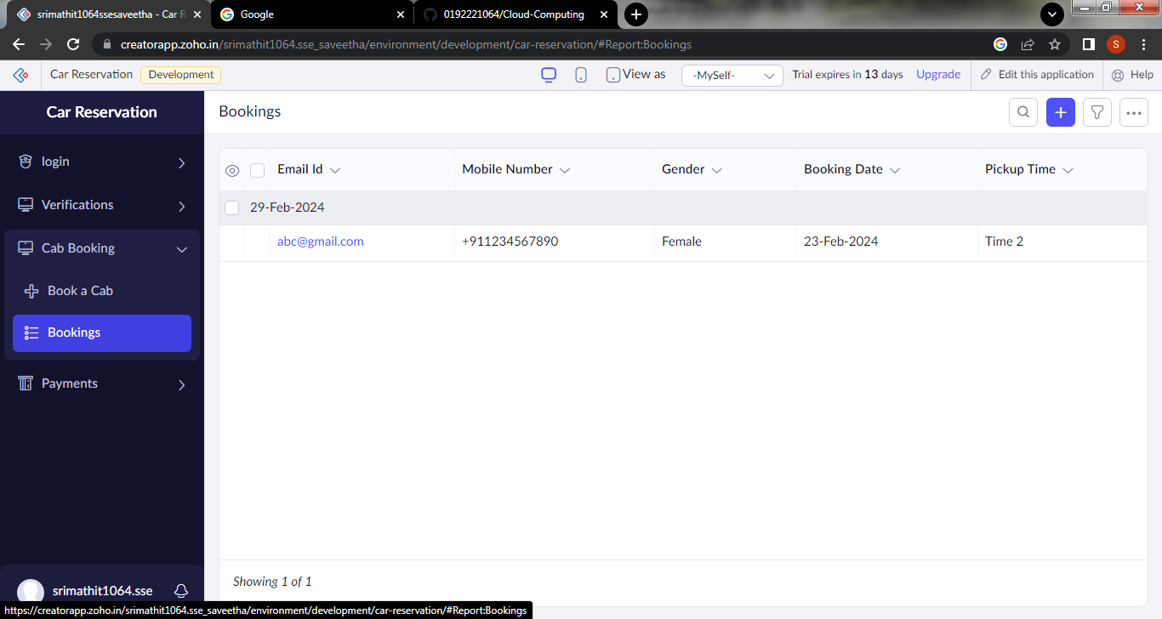

**Step 12:** Mobile view of the software

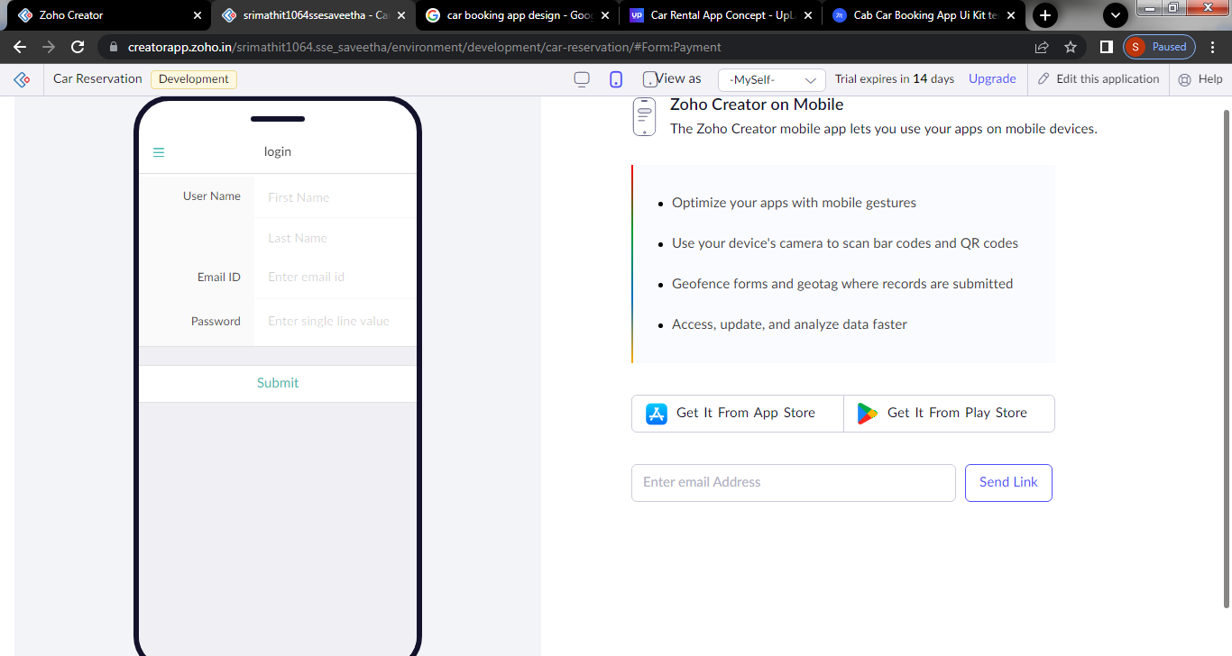

**Step 13:** click the tablet icon to see the output in tablet view

